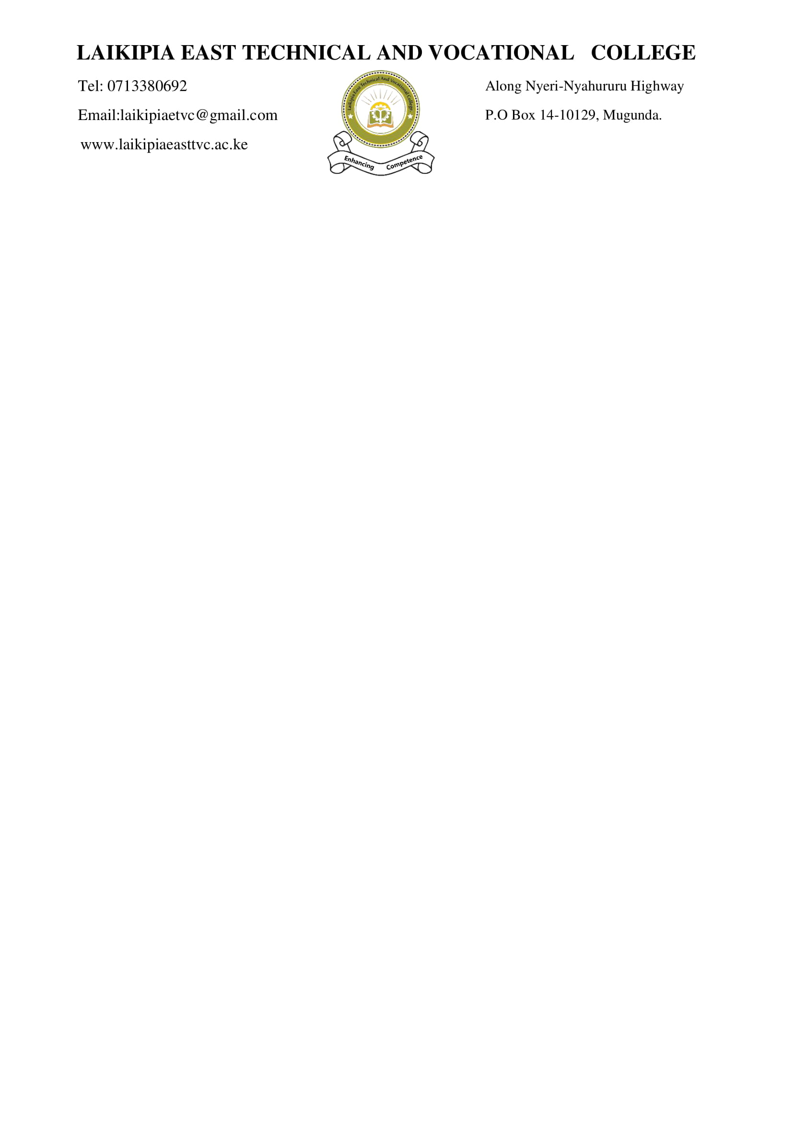

**SCHEME OF WORK (CBET CLASSES)**

|  |  |  |  |  |  |  |  |  |  |
| --- | --- | --- | --- | --- | --- | --- | --- | --- | --- |
| **DEPARTMENT: ICT** | | | | **NAME OF TRAINER: DUNCAN NDEGWA** | | | **NUMBER OF TRAINEES:** | | |
| **UNIT CODE:** | | | | **TERM: I** | **DATE OF PREPARATION: 27/04/2025** | | **CLASS: ICT M25** | | |
| **COURSE:** | | | | | | | **LEVEL: MODULE I** | | |
| UNIT OF COMPETENCE: DEMONSTRATE DIGITAL LITERACY | | | | | | | **DATE OF REVISION: 3/5/2025** | | |
| **SCHEDULE** | | | | | | | | | |
| **WEEK** | **NUMBER OF HOURS** | **ELEMENT / LEARNING OUTCOME** | **SUB -TOPIC/ CONTENT** | **SPECIFIC OBJECTIVES / PERFORMANCE CRITERIA** | | **ACTVITIES** | | **REFERENCE/ RESOURCES** | **REMARKS** |
|  | **REPORTING AND REGISTRATION** | | | | | | | | |
|  | 6 | Introduction to Microsoft Word | - Interface overview - Ribbon & Tabs - File management | Identify Word UI elements and create/save a document | | * Taking notes * Class discussion * Questions and answers * Practical Demo | | * E-books * Hobbs, R. (2017). *Create to learn: Introduction to digital literacy*. John Wiley & Sons. |  |
|  | 6 | Text Editing & Formatting | Fonts, font sizes, styles - Paragraph alignment - Bullets/Numbering | - Fonts, font sizes, styles - Paragraph alignment - Bullets/Numbering | | * Taking notes * Class discussion * Questions and answers * Practical Demo | | * E-books * Hobbs, R. (2017). *Create to learn: Introduction to digital literacy*. John Wiley & Sons. |  |
|  | 6 | Tables and Images | |  | | --- | | Images |  |  | | --- | | - Inserting and formatting tables - Adding and editing images |   Page Layout & Printing | Create a document with tables and images  - Margins - Orientation - Page size - Print preview | | * Taking notes * Class discussion * Questions and answers * Practical Demo | | * E-books * Hobbs, R. (2017). *Create to learn: Introduction to digital literacy*. John Wiley & Sons. |  |
|  | 6 | Excel Interface & Data Entry | Excel UI overview - Cell referencing - Entering data | Navigate Excel and input structured data. | | * Taking notes * Class discussion * Questions and answers * Practical Demo | | * E-books * Hobbs, R. (2017). *Create to learn: Introduction to digital literacy*. John Wiley & Sons. |  |
|  | 6 | Formatting and Simple Formulas | - Cell formatting - AutoSum - Basic functions: SUM, AVERAGE | Use formulas to analyze data | | * Taking notes * Class discussion * Questions and answers * Practical Demo | | * E-books * Hobbs, R. (2017). *Create to learn: Introduction to digital literacy*. John Wiley & Sons. |  |
|  | 6 | Charts and Graphs  Sorting, Filtering & Printing | - Column, Line, Pie charts - Chart elements and labels  - Sort by values - Apply filters - Set print area | Visualize data using charts  Organize data for presentation and printing | | * Taking notes * Class discussion * Questions and answers * Practical Demo | | * E-books * Hobbs, R. (2017). *Create to learn: Introduction to digital literacy*. John Wiley & Sons. |  |
|  | 6 | PowerPoint Basics | - Interface - Slide layouts - Inserting text and images | Create a simple multi-slide presentation | | * Taking notes * Practical session * Class discussion * Questions and answers * Practical class | | * E-books * Hobbs, R. (2017). *Create to learn: Introduction to digital literacy*. John Wiley & Sons. |  |
|  | 6 | Design & Transitions | - Themes and templates - Transitions - Slide timing | Improve visual presentation and flow | | * Taking notes * Practical session * Class discussion * Questions and answers * Practical class | | * E-books * Hobbs, R. (2017). *Create to learn: Introduction to digital literacy*. John Wiley & Sons. |  |
|  | 6 | Animations and Slide Show | - Custom animations - Rehearse timings - Running slide shows | Deliver an engaging slide show | | * Taking notes * Practical session * Class discussion * Questions and answers | | * E-books * Hobbs, R. (2017). *Create to learn: Introduction to digital literacy*. John Wiley & Sons. |  |
|  | 6 | Final Project Presentation | - Word, Excel, and PowerPoint integration | Present project using all 3 MS Office tools | | * Taking notes * Practical session * Class discussion * Questions and answers * Project evaluation | | * E-books * Hobbs, R. (2017). *Create to learn: Introduction to digital literacy*. John Wiley & Sons. |  |
|  | **REVISION AND EXAMS** | | | | | | | | |

CHECKED BY VERIFIED BY:

NAME: NAME:

DESIGNATION DESIGNATION